**SYNOPSIS**

**On**

**“Online Grocery Shopping System”**

**Submitted for partial fulfillment of the requirements**

**for the award**

**of**

**Degree of BCA**

**Of**

**MAULANA ABUL KALAM AZAD UNIVERSITY OF TECHNOLOGY, WEST BENGAL**

**Under the guidance of**

**Prof. Tanmoy Halder**

**Submitted by**

**Sumit Mukherjee Subhadip Chakraborty**

**(32301216011) (32301216015)**

**Subhadeep Chatterjee Shantu Sharma**

**(32301216017) (32301216031)**

**Subhadeep Saha Tanmoy Kesh**

**(32301216016) (32301216006)**

**Dr. B.C. Roy Engineering College, Durgapur**

**Academy of Professional Courses**

|  |
| --- |
| **CONTENTS** |
| **Introduction** |
| **Methodology** |
| **Tool and Environment Use** |
| **Feasibility Study** |
| **System Analysis** |
| **Advantages and Disadvantages of the project** |
| **Application of the Project** |
| **References** |

**INTRODUCTION**

# Introduction: Online Grocery Shopping is the norm these days. There are lot of successful websites such as BigBasket.com, askmegrocery.com etc in this space. Purpose of Online Grocery Shopping system is to allow customer to shop virtually using internet. Computerization of online store will increase the ease, efficiency and reduce the chances of manual errors. With the popularity of PCs, and mobiles easy access to Internet and World Wide Web (WWW), Internet is increasingly used by consumers as a channel for shopping, place order & other operations.

# Objective:

* The main objective of proposed system, is used to provide Online Grocery Shopping solution to consumers.
* It will automate some of the basic operations of an online store. Scope would be to provide basic functionalities using a web application so that those manual process can be automated.
* It will include to provide administration access to vendors and admins and user specific access to customers.
* The project is all about providing users the opportunity to book their food items from anywhere without physically going to book.
* Our aim is to provide the service to every customer to register himself, then use his account to book grocery items online from anywhere, anytime. The project also gives each customer the chance to go through the menu, descriptions, images, of all the food items which he wants to book.
* This Project provides security for the users with the use of Login with the user-id and Password, so that unauthorized users cannot use anyone else’s account. The only authorized will have proper access authority can access the software.

# BLOCK DIAGRAM

# REGISTER HOME LOGIN

# NEW USER USER ADMIN

# -ADD PRODUCT -MODIFY PRODUCT

# -MODIFY ORDERS

# VIEW ORDER LIST

# CREATE ACCOUNT

# 

# METHODOLOGY

This Document plays a vital role in the software development life cycle (SDLC) as it describes the complete requirement of the system. It is meant for use by the developers and will be the basic during testing phase. Any changes made to the requirements in the future will have to go through formal change approval process.

ITERATIVE WATERFALL MODEL was being chosen because all requirements were known beforehand and the objective of our software development is the computerization/automation of an already existing manual working system.

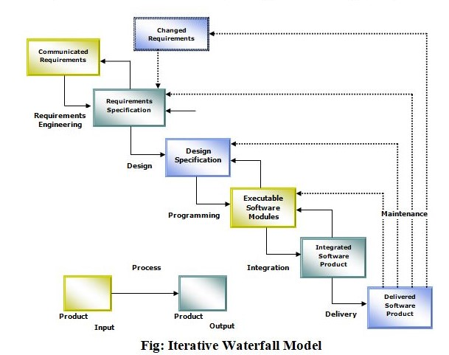

The developer is responsible for:

* Developing the system, which meets the SRS and solving all the requirements of the system?
* Demonstrating the system and installing the system at client's location after the acceptance testing is successful.
* Submitting the required user manual describing the system interfaces to work on it and also the documents of the system.

# TOOL & ENVIRONMENT USE

**Software Requirements:**

* **OS**: Windows 10
* **Database**: My SQL (Free-Open source)
* **IDE**: Adobe Dreamweaver (Free-Open source)
* **Server**: XAMPP Server (Free-Open source)
* **Language**: PHP5 (Free-Open source)
* **Front End**: Browser with support for Java script

**Hardware Components:**

* Processor – Dual Core
* Hard Disk – 1 TB
* Memory – 4GB RAM
* Mouse – Any Standard
* Keyboard – Any Standard
* Monitor – Any color monitor
* Local Area Network Preferable

**Feasibility Study**

An important outcome of the preliminary investigation is the determination that system requested is feasible. In our case, System will allow basic transactions online for customers and administrators for which data will be stored in database. Records in DB will be used for authentication, and all other operations. Further there are three aspects in the feasibility study portion of the preliminary investigation

* **Economic Feasibility:**

Are there sufficient benefits in creating the system to make the costs acceptable? Or, are the costs of not creating the system so great that it is advisable to undertake the project? These are the important questions to be answered in economic feasibility. Proposed system will not face any economic constraint as it will be developed by students only. And it will help to automate manual processing, which will save time and money. This will provide economic benefits.

* **Operational Feasibility:**

Will the system be used if it is developed and implemented? Will there be resistance from users that will undermine the possible application benefits? When we look from this perspective, we don’t see any risk in implementing and making it operational. This project will help everyone, as it is planned to be more reliable, maintainable, affordable and producible.

* **Technical Feasibility:**

Can the work for the project be done with current equipment, existing software technology and available personnel? These are the questions which needs to be answered to check Technical feasibility. Project will be developed using Java-JEE and back end as mySQL which will store details related to this project. There are basic requirement of hardware to run this application. This application will be web application so this application can be accessed by using any device like (Personal Computers, Laptop and with some hand held devices) provided they are on same network.

# SYSTEM ANALYSIS

System analysis is a process of gathering and interpreting facts, diagnosing problems and the information to recommend improvements on the system. It is a problem solving activity that requires intensive communication between the system users and system developers. System analysis or study is an important phase of any system development process. The system is studies to the minutest detail and analyzed. The system analyst plays the role of the interrogator and dwells deep into the working of the present system. The System is viewed as a whole and the input to the system are identified. The outputs from the organization are traced to the various processes. System analysis is concerned with becoming aware of the problem, identifying the relevant and Decisional variables, analysis and synthesizing the various factors and determining an optimal or at least a satisfactory solution or program of action.

A detailed study of the process must be made by various techniques like interviews, questionnaires etc. The data collected by these sources must be 9scrutinized to arrive to a conclusion. The conclusion is an understanding of how the system functions. This system is called the existing system. Now the existing system is subjected to close study and problem area are identified. The designer now functions as a problem solver and tries to sort out the difficulties that the enterprise faces. The solutions are given as proposals. The proposal is then weighed with the existing system analytically and the best one is selected. The proposal is presented to the user for an endorsement by the user .The proposal is reviewed on user request and suitable changes are made. This is loop that ends as soon as the user is satisfied with proposal.

**APPLICATION OF THE PROJECT**

**1.Convenient:** Online Grocery Shopping System is convenient. People don’t have to leave their homes to visit stores for Grocery Shopping. They can login to the internet, look for good products and then proceed to buy and order for their products.

**2.Range of choices:** It offers a great variety of options they usually have larger stocks of products than a physical store. Therefore, whatever products we need we can easily find it here.

**3.Timesaving:** We can save a lot of time and money by using Online Grocery Shopping System. People who live far from retail outlets and those with busy schedules can find this advantageous. They can buy multiple products at a minimum time.

**4.Affordable:** There are no middle men present between the customer and manufacturer. Customers buy products directly from the manufacturers.So, their products are considerably cheaper than those in local stores.

**Advantages:**

* **Performance**: Most of Operations and tasks in underlined system are repetitive and time consuming. Also there are chances of manual errors in the system. So an efficient, effective, fast system is desired. Hence this web based computerized system is undertaken which is very fast and user friendly.
* **Ease & Efficiency**: The basic need of this website is efficiency and simplicity. This website is efficient as it provides easy browsing & data entry for user. Users can easily view all the related operations along with all relevant details.
* **Control**: The complete control of the project is under the hands of authorized person. Only customer can access their own account. All control is under the administrator and members have the rights to just see their concerned records and transactions.
* **Security**: Security is one of the main concerns for any modern application. So, security is the important criteria for the purposed system. Proper authentication and authorization is implemented so that only right person will get right access.

**Disadvantages of the Project:**

* System would be a basic project which is intended to provide base for further development.
* Other functionalities are supposed to be developed as per custom need on this framework.
* User needs to have access to website either on LAN or other network.

**Future Scope:**

* There will be lot of scope to improve this project, since currently basic functionality would be provided.
* Shopping Cart feature will be added to improve this minor project into a major project. So that, users can add multiple items into the cart and can checkout of more than one product at one time.
* Online payment method will be a great future scope of our project. Thus, consumers will be able to pay through Debit cards or e-wallets in online payment. Then there will be no need to carry cash.
* Some of the modules to improve are admin part such as personalized recommendations, discount & offer management. For customers, notification & messaging etc can be improved. These can be developed to make it more effective.

**References:**

* <https://www.youtube.com>
* <https://www.tutorialspoint.com>
* <https://www.bigbasket.com>
* <https://www.w3schools.com>